SOFTWARE REQUIREMENT SPECIFICATION

ONLINE SHOPPING MART

BY

AKASH KANNAN T G

INDEX PAGE

1.Purpose…………………………………………………………….3

2. Intended Audience………………………………………….3

3. Scope……………………………………………………………….4

4. User Interface………………………………………………….4

5. System Interface……………………………………………..5

6. Constraints……………………………………………………..6

7. User Characteristics………………………………………..7

8. Functional Requirement…………………………………8

9. Non Functional Requirement…………………………9

10.Use Case Diagram…………………………………………10

11. Class Diagram………………………………………………11

12. Sequence Diagram………………………………………11

**PURPOSE:**

An online shopping mart serves as a digital marketplace where consumers can browse, select, and purchase goods or services from the comfort of their homes or any location with internet access. With its primary goal of providing convenience, online shopping marts offer a diverse array of products and services, eliminating the need for consumers to physically visit traditional brick-and-mortar stores. Operating 24/7, these platforms cater to global audiences, enabling purchases from sellers worldwide and expanding market reach for businesses. Cost savings, another significant benefit, stem from competitive pricing and discounts, coupled with reduced transportation expenses. Moreover, online shopping marts facilitate informed decision-making through detailed product information, including descriptions and customer reviews, while offering various payment options for added flexibility

**INTENDED AUDIENCE:**

The intended audience for the online shopping mart consists of various stakeholders who interact with or are impacted by the platform. Primary users encompass customers seeking to browse, select, and purchase products or services, alongside administrators tasked with managing inventory, processing orders, and maintaining the platform. Secondary users include developers responsible for software development and maintenance, designers ensuring a visually appealing and user-friendly interface, customer support representatives aiding with inquiries and issues, and the marketing team driving promotion and customer engagement. Other stakeholders, such as business owners or managers, and third-party service providers offering essential support services, also play integral roles. Understanding the diverse needs and objectives of these stakeholders is paramount in crafting and maintaining a successful online shopping mart that effectively caters to its intended audience

**SCOPE:**

The online shopping mart will include features for browsing products, adding items to a shopping cart, securely processing payments, managing user accounts, and facilitating order fulfillment. Additionally, administrative functionalities for managing inventory, processing orders, and generating reports will be included.

**USER INTERFACE**

The user interface (UI) of the online shopping mart is designed to provide an intuitive and seamless experience for customers as they interact with the platform. Key elements of the UI include:

Homepage: The homepage serves as the entry point for users and features visually appealing elements such as banners, featured products, and promotional offers to attract and engage customers.

Navigation Menu: A clear and easily accessible navigation menu allows users to browse product categories, access their account, view shopping cart, and navigate to other sections of the platform.

Product Listings: Product listings display images, descriptions, prices, and options for users to browse and select items of interest. Filters and sorting options help users refine their search results.

Product Details Page: Detailed product pages provide comprehensive information about individual products, including specifications, reviews, related items, and options for customization (e.g., size, color).

Shopping Cart: The shopping cart displays a summary of selected items, quantities, prices, and a checkout button. Users can easily edit or remove items from their cart.

Checkout Process: The checkout process guides users through entering shipping and billing information, selecting payment methods, applying discount codes, and reviewing their order before finalizing the purchase.

User Account: Registered users have access to a personalized account dashboard where they can manage their profile, view order history, track shipments, and manage payment methods.

Search Functionality: A search bar allows users to quickly find specific products by entering keywords, with autocomplete suggestions and filters to refine search results.

Customer Support: Accessible customer support options such as live chat, FAQs, and contact forms provide assistance to users with inquiries, issues, or feedback.

**SYSTEM INTERFACE:**

The system interface of the online shopping mart involves interactions between various components and external systems to ensure seamless operation and data exchange. Key components of the system interface include:

Database Management System (DBMS): The online shopping mart interacts with a relational database management system (e.g., MySQL, PostgreSQL) to store and retrieve data related to products, orders, customers, and inventory.

Payment Gateway Integration: Integration with third-party payment gateways (e.g., PayPal, Stripe) enables secure processing of online transactions, including credit/debit card payments, digital wallets, and other payment methods.

Shipping and Logistics Integration: Integration with shipping and logistics providers (e.g., FedEx, UPS) facilitates real-time shipping rate calculation, label generation, package tracking, and order fulfillment.

Inventory Management System: Integration with an inventory management system ensures accurate tracking of product availability, stock levels, and updates inventory data in real-time as orders are processed.

Security Protocols: Implementation of security protocols such as HTTPS encryption, secure socket layer (SSL) certificates, and data encryption ensures secure communication and data protection during user interactions and transactions.

Content Delivery Network (CDN): Integration with a CDN enhances website performance by caching static content, reducing page load times, and distributing content across multiple servers for improved scalability and reliability.

APIs and Web Services: Exposing APIs and web services allows integration with third-party applications, affiliate programs, and marketing platforms for data exchange and interoperability.

Analytics and Reporting Tools: Integration with analytics and reporting tools (e.g., Google Analytics, custom analytics platforms) enables tracking of user behavior, sales metrics, conversion rates, and performance insights for data-driven decision-making.

Content Management System (CMS): Integration with a CMS (e.g., WordPress, Drupal) facilitates content updates, product management, and dynamic content generation for marketing campaigns, promotions, and site maintenance.

**CONSTRAINTS:**

Technology Stack Compatibility: The online shopping mart must be compatible with the chosen technology stack, including programming languages, frameworks, and third-party integrations.

Regulatory Compliance: Compliance with legal and regulatory requirements, such as data protection laws (e.g., GDPR), consumer protection regulations, and payment card industry standards (PCI DSS), must be ensured.

Budgetary Constraints: The development and maintenance costs of the online shopping mart must align with the available budget.

Scalability: The platform must be designed to handle scalability requirements, accommodating potential growth in user base, product catalog, and traffic volume.

Security Requirements: Implementation of robust security measures, including encryption, authentication, authorization, and secure payment processing, to protect user data and prevent unauthorized access.

Performance Expectations: The online shopping mart must meet performance expectations in terms of page load times, responsiveness, and system availability.

Integration Dependencies: Integration with third-party services, such as payment gateways, shipping providers, and analytics platforms, must be implemented effectively.

Usability and Accessibility: The platform must adhere to usability and accessibility standards to ensure a user-friendly experience for all users, including those with disabilities.

**USER CHARACTERISTICS:**

Diverse Demographics: Users of the online shopping mart may vary in demographics, including age, gender, location, and socio-economic background.

Technical Proficiency: Users may have varying levels of technical proficiency, ranging from tech-savvy individuals to those with limited experience in using digital platforms.

Shopping Preferences: Users may have different preferences when it comes to browsing, searching, and purchasing products online, such as preferred payment methods, shipping options, and product categories.

Privacy Concerns: Users may have concerns about the privacy and security of their personal information, including payment details and browsing history.

Device and Connectivity: Users may access the online shopping mart from a variety of devices, including desktops, laptops, tablets, and smartphones, with varying screen sizes and internet connectivity speeds.

Expectations and Behavior: Users may have specific expectations regarding the shopping experience, including ease of navigation, product availability, pricing transparency, and customer support responsiveness.

Trust and Reputation: Users may rely on trust signals, such as user reviews, ratings, and brand reputation, when making purchasing decisions on the online shopping mart.

**FUNCTIONAL REQUIREMENT**

**User Authentication and Authorization:**

Users must be able to register for an account and log in securely.

Different user roles (customer, administrator) with appropriate permissions should be defined.

**Product Catalog:**

Users should be able to browse products by category, search for specific items, and view detailed product descriptions.

Each product listing should include images, prices, availability status, and related products.

**Shopping Cart Management**:

Users should be able to add items to their shopping cart, update quantities, and remove items.

The shopping cart should display the subtotal, taxes, and total price.

**Checkout Process:**

Users should be guided through a seamless checkout process, including shipping and billing information input.

Multiple payment options (credit/debit cards, digital wallets, etc.) should be supported.

Secure payment processing and encryption of sensitive data must be implemented.

**Order Management:**

Users should be able to view order history, track order status, and receive email notifications for order updates.

Administrators should have access to order management tools to process orders, update order status, and handle returns/refunds.

**Inventory Management**:

Administrators should be able to add, edit, and remove products from the inventory.

Inventory levels should be automatically updated upon order placement.

**NON FUNCTIONAL REQUIREMENT**

**Performance:**

The system should be able to handle a high volume of concurrent users without significant performance degradation.

Page load times should be optimized for a smooth user experience.

**Security:**

User authentication and sensitive data transmission must be secured using encryption protocols (e.g., HTTPS).

Protection against common security threats such as SQL injection and cross-site scripting (XSS) must be implemented.

**Scalability:**

The system should be designed to accommodate future growth in terms of user base and product catalog size.

**Usability:**

The user interface should be intuitive and easy to navigate for both customers and administrators.

Accessibility standards should be followed to ensure usability for users with disabilities.

**Reliability:**

The system should be highly available, with minimal downtime for maintenance and updates.

Data integrity measures should be in place to prevent data loss or corruption.

**USE CASE DIAGRAM:**

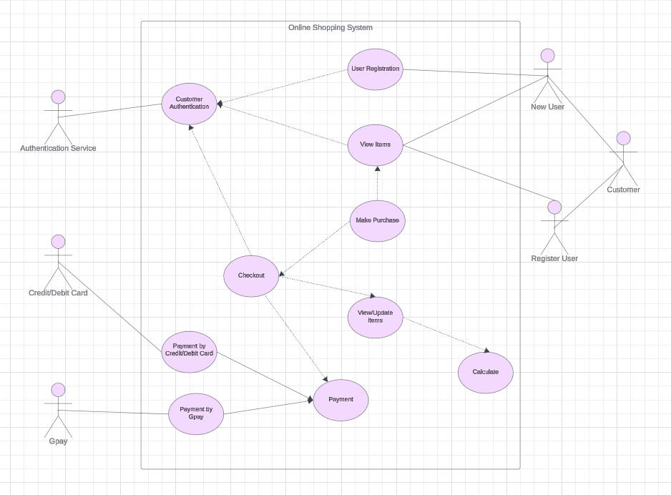

**CLASS DIAGRAM:**

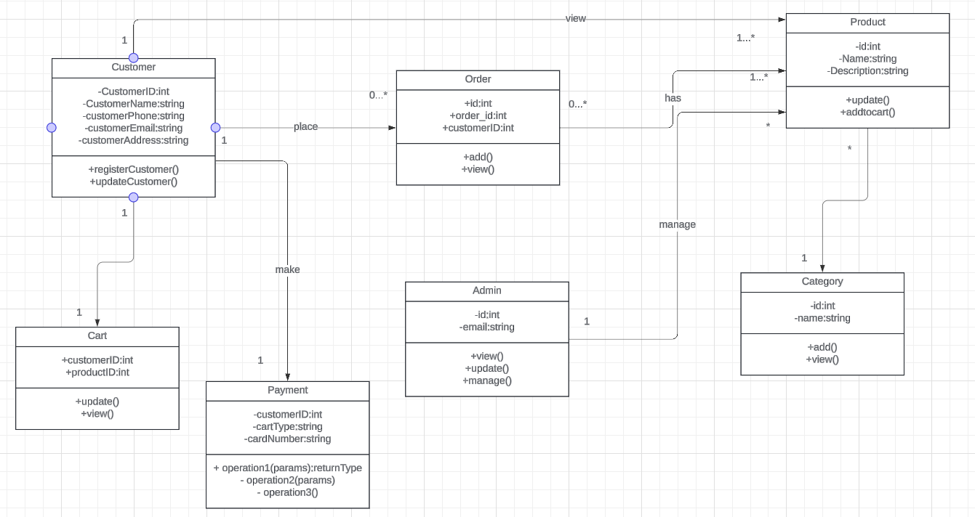

**SEQUENCE DIAGRAM:**

